AWS RDS (PaaS) Database Setup & Application Integration

1. Introduction

New Approach (PaaS – RDS)
In this project:
- AWS provides a fully managed database service
- No need to:
  - Install MySQL
  - Manage OS
  - Handle backups manually
This model is called Platform as a Service (PaaS)
Core Idea
Instead of:
“I install MySQL on EC2”
Now:
“AWS provides a ready-to-use MySQL database (RDS)”

2. Objective
- Create a MySQL database using AWS RDS (Free Tier)
- Connect application to RDS
- Perform user registration and login
- Store and retrieve data from RDS

3. Prerequisites
- AWS Account
- Basic knowledge of MySQL
- EC2 instance (for application)
- MySQL client installed

4. Implementation Steps

Step 1: Login to AWS Console
- Open AWS Console
- Search for RDS
- Open RDS Dashboard

Step 2: Create Database
- Click Create database
- Choose:
  - Easy create (recommended)

Step 3: Choose Database Engine
- Engine type: MySQL
- Version: Default
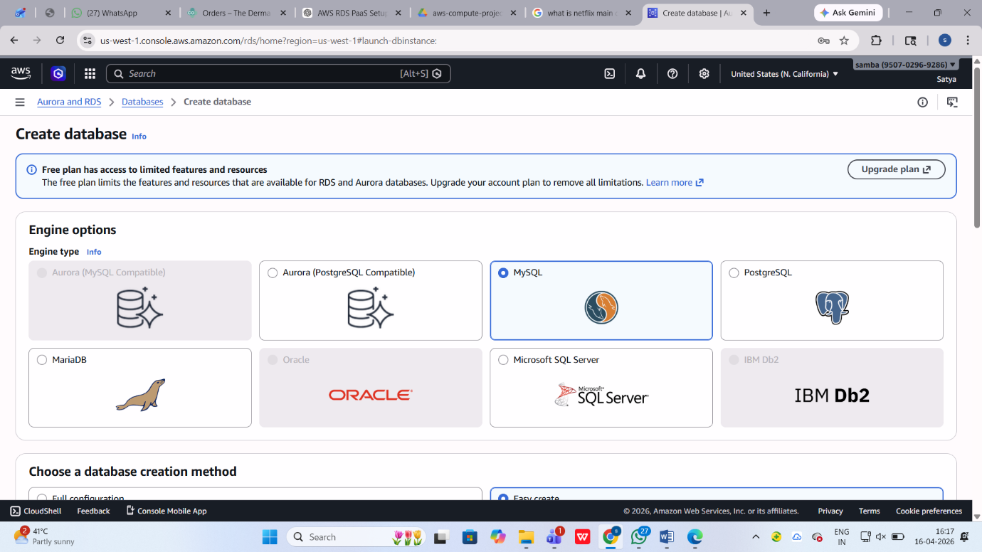

Step 4: Select Free Tier
- Choose: Free tier
Important: Prevents billing charges
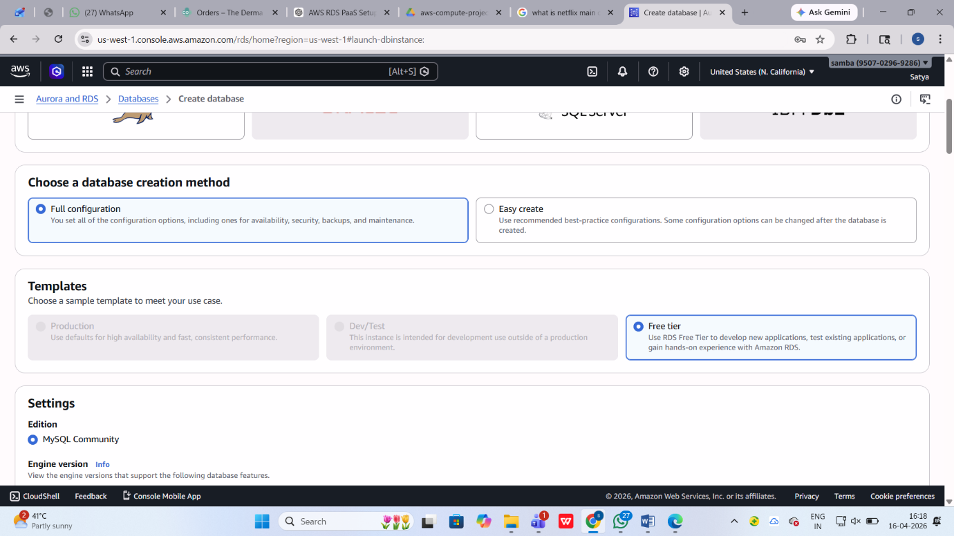

Step 5: Configure Credentials

Enter:
- DB instance identifier: database1
- Username: admin
- Password: YourPasswordadmin123
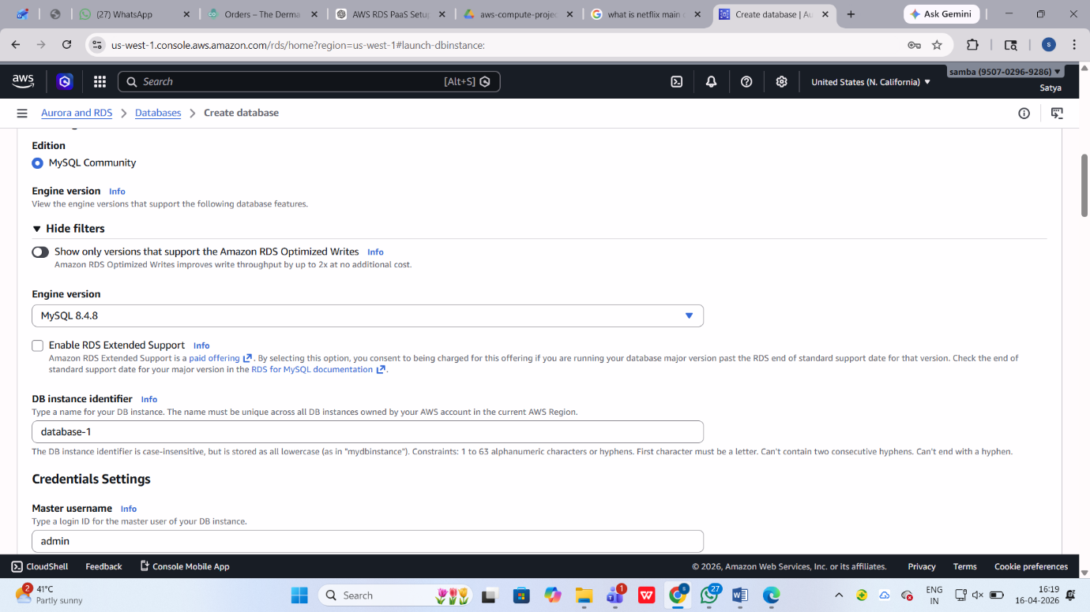

Step 6: Instance Configuration
- DB instance class: db.t3.micro (Free Tier)

✅ Step 7: Storage Configuration
- Storage: Default (20 GB)

✅ Step 8: Connectivity Setup (Critical Step)
Configure:
- VPC: Default
- Public access: YES
- Security Group:
  - Allow MySQL (Port 3306)
  - Source: My IP

Step 9: Additional Configuration
- Initial database name: jet

✅ Step 10: Create Database
- Click Create Database
- Wait 5–10 minutes
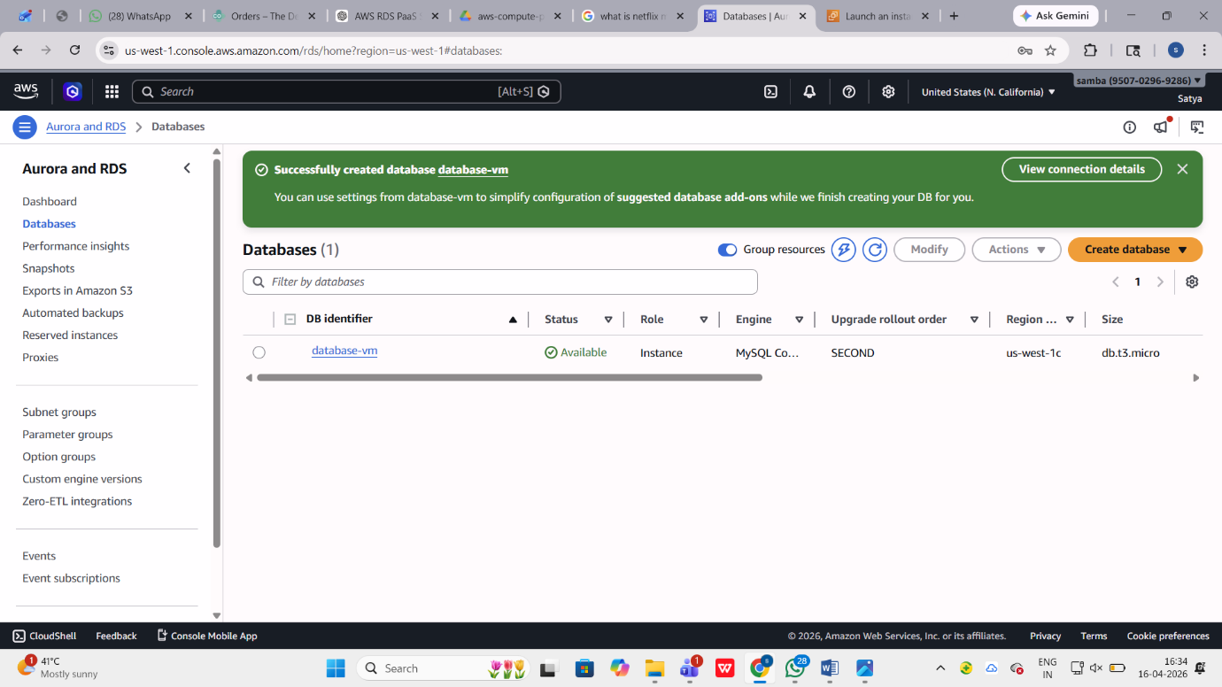

Step 11: Get Database Endpoint
- Open created DB
- Copy Endpoint
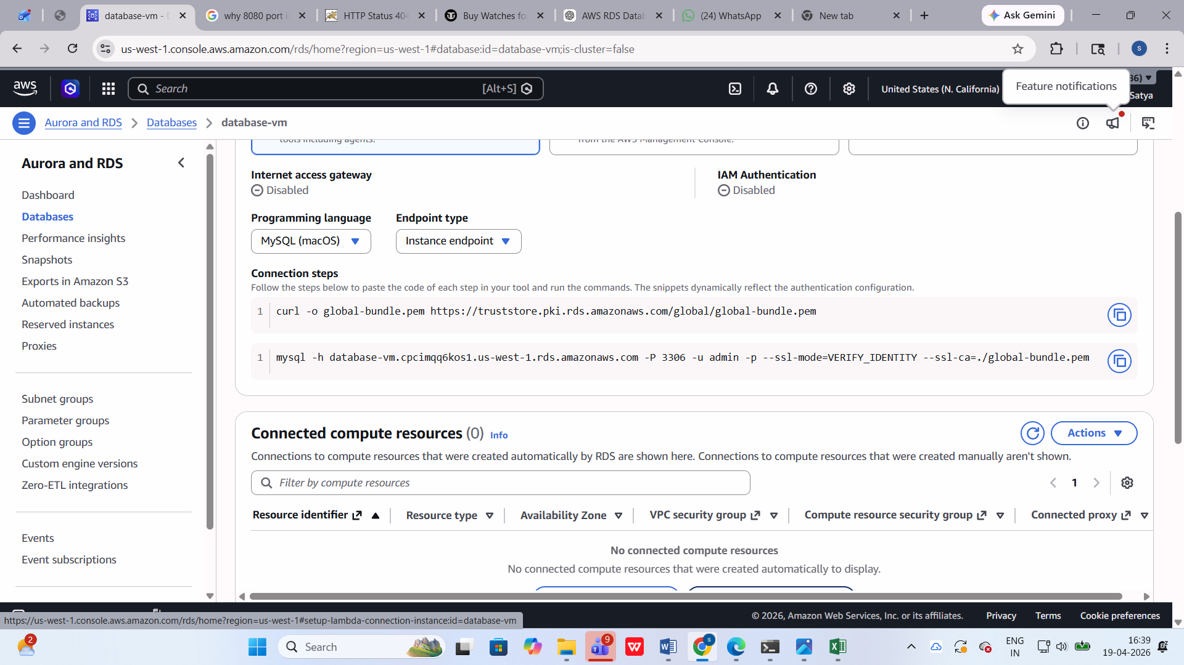

Application VM Setup (EC2)

Step 1: Launch EC2 Instance
- AMI: Ubuntu
- Instance type: t2.micro (Free tier)
- Allow:
  - SSH (22)
  - HTTP (80)
  - Custom TCP (8080) → for Tomcat
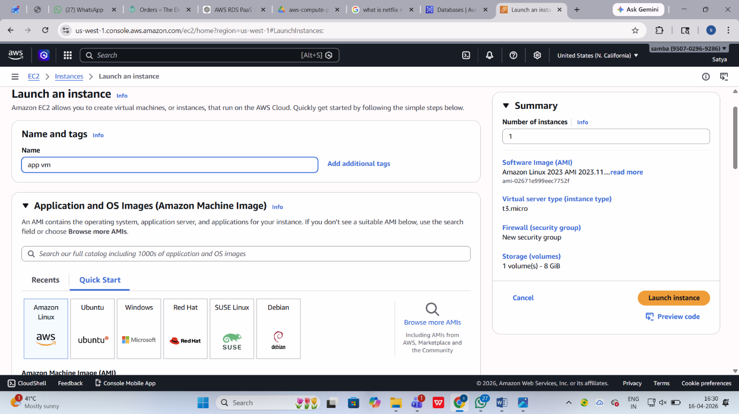

✅ Step 2: Connect to EC2
ssh -i key.pem ubuntu@<EC2-PUBLIC-IP>

Step 3: Install Java (Required for Tomcat)
sudo apt update
sudo apt install openjdk-11-jdk -y
java -version
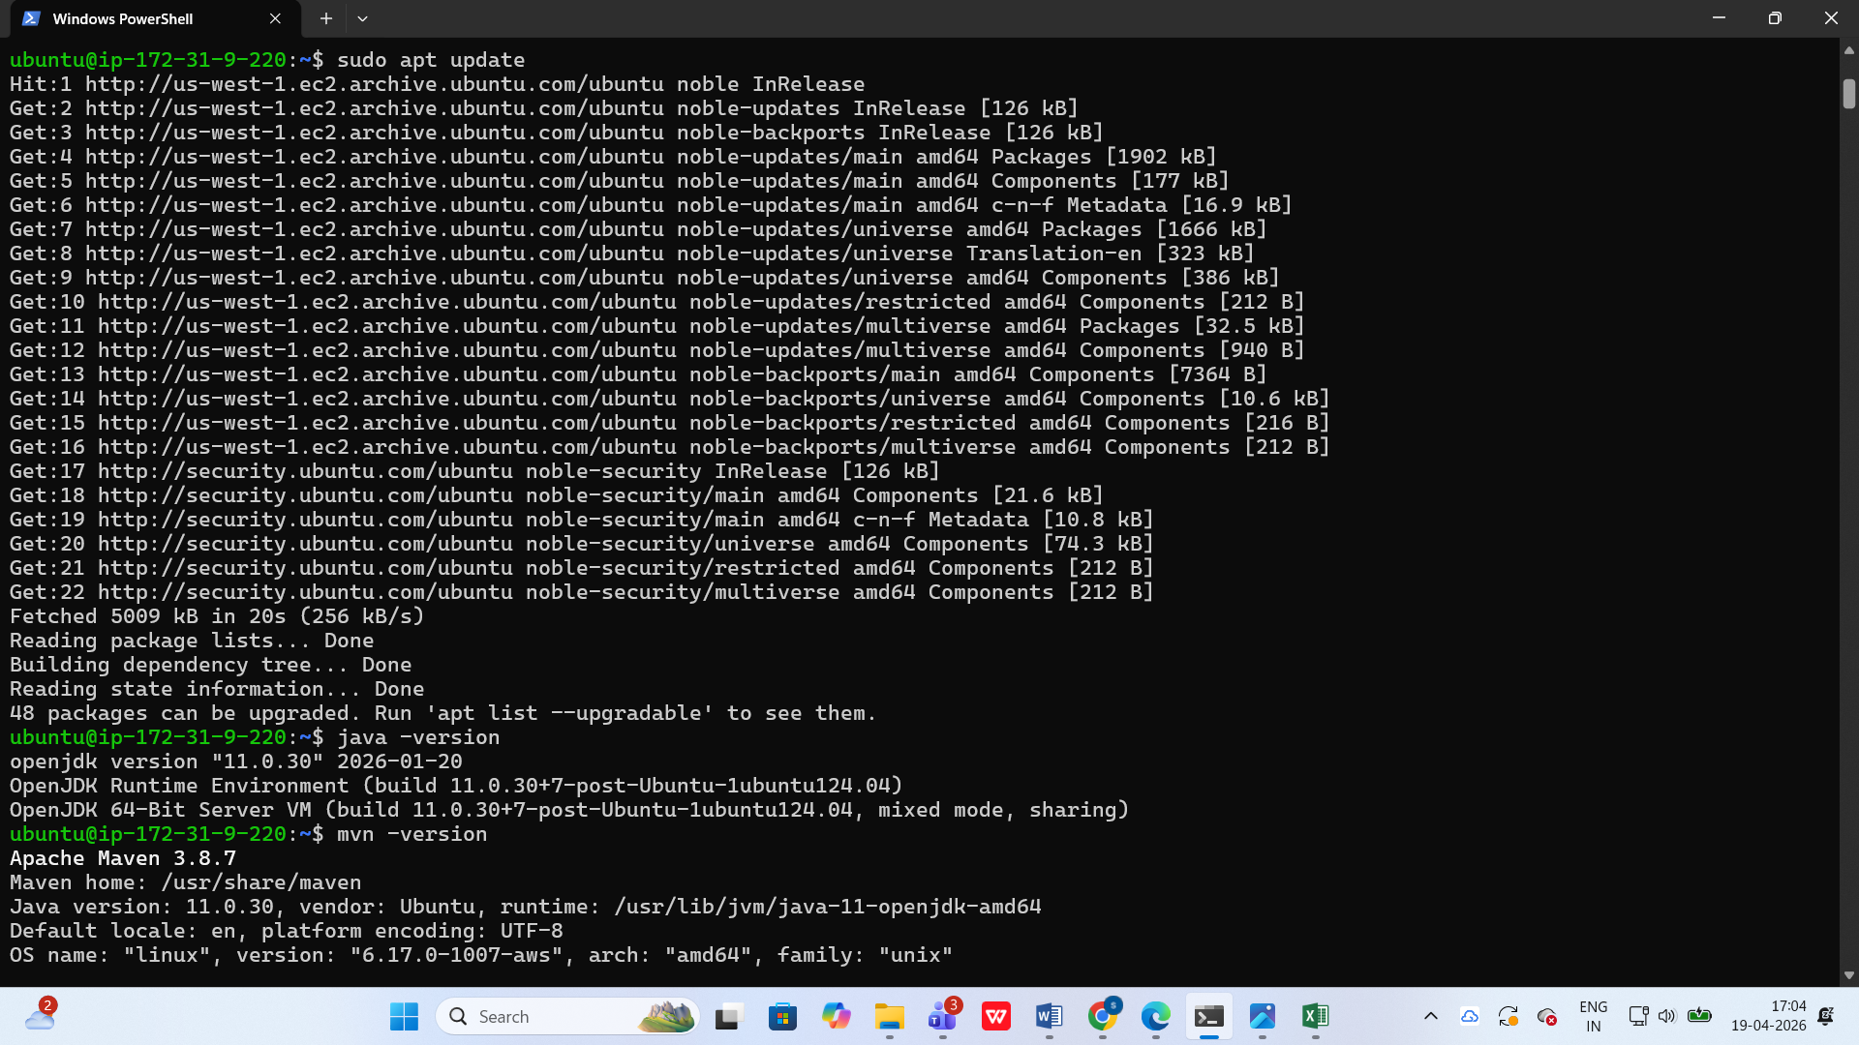

✅ Step 4: Install Apache Tomcat
Download Tomcat:
wget https://downloads.apache.org/tomcat/tomcat-9/v9.0.91/bin/apache-tomcat-9.0.91.tar.gz
Extract:
tar -xvzf apache-tomcat-9.0.91.tar.gz
Move:
sudo mv apache-tomcat-9.0.91 /opt/tomcat
Start Tomcat:
cd /opt/tomcat/bin
./startup.sh
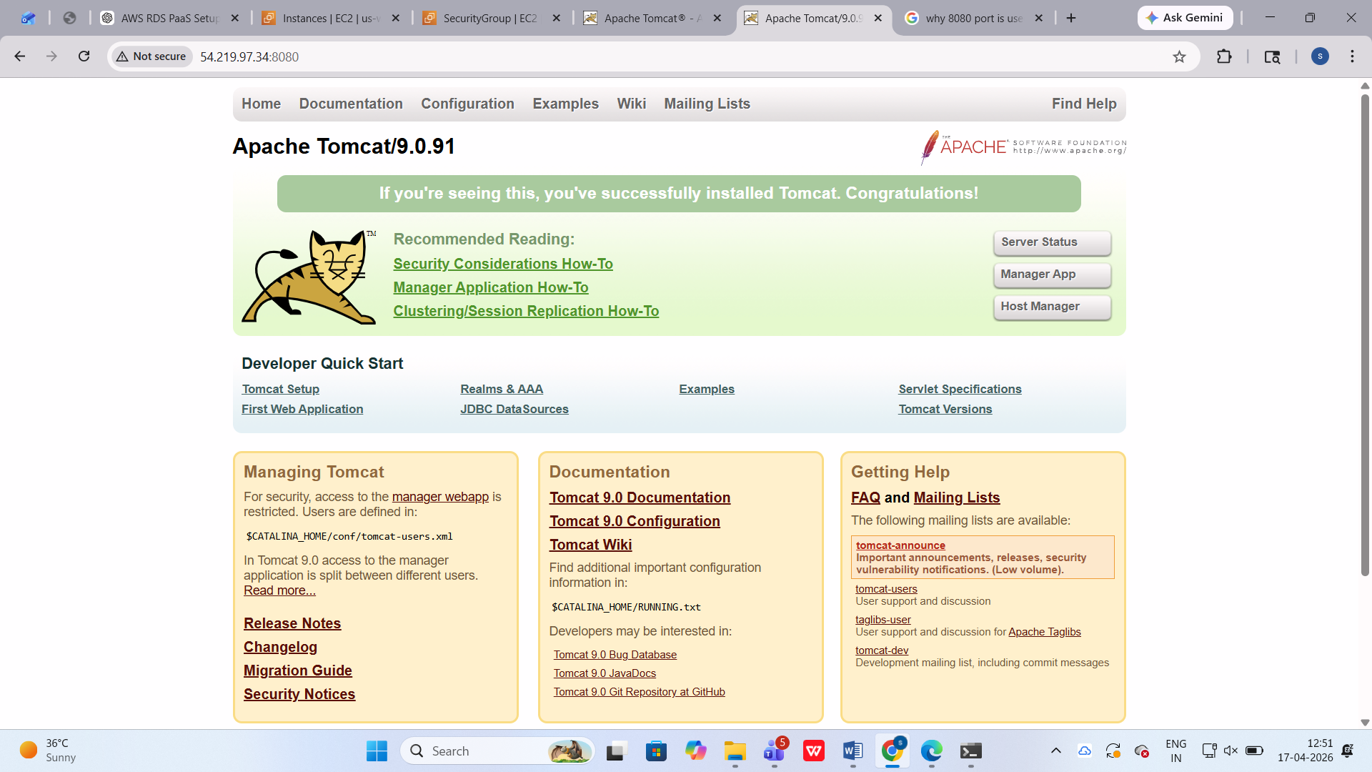

Step 5: Install Git
sudo apt install git -y
git --version

Step 6: Install Maven
sudo apt install maven -y
mvn -version
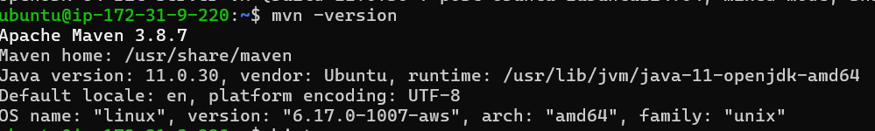

Step 7: Clone Application Code
git clone <YOUR-GITHUB-REPO-LINK>
cd <PROJECT-FOLDER>
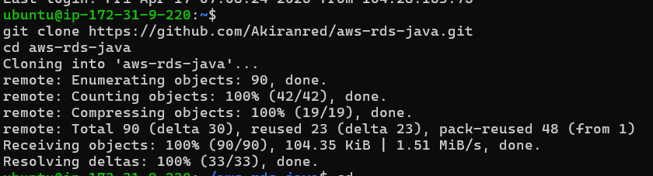

Step 8: Build Application using Maven
mvn clean package
👉 Output: .war file

Step 9: Deploy WAR to Tomcat
cp target/*.war /opt/tomcat/webapps/
Restart Tomcat:
cd /opt/tomcat/bin
./shutdown.sh
./startup.sh

5. Connecting to RDS Database
From EC2 instance:
mysql -h <RDS-ENDPOINT> -u admin -p
- Enter password when prompted
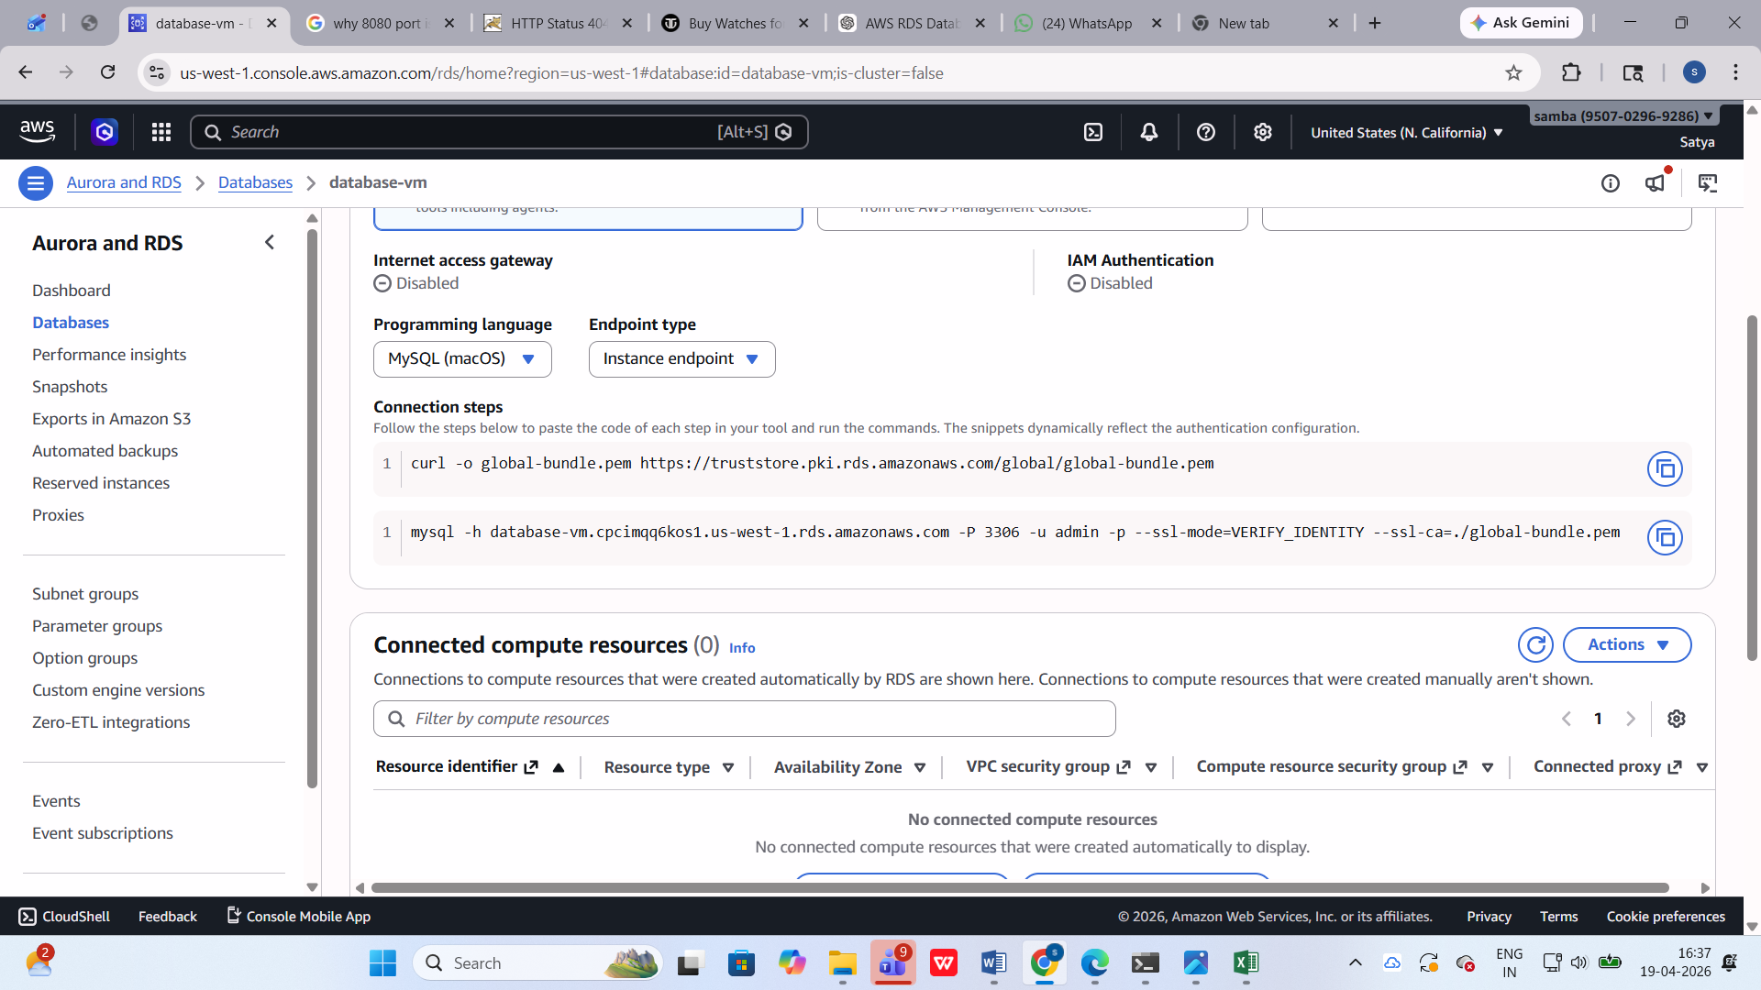

6. Database & Table Creation
Run:
USE jet;
CREATE TABLE USER (
id int(10) unsigned NOT NULL auto_increment,
first_name varchar(45) NOT NULL,
last_name varchar(45) NOT NULL,
email varchar(45) NOT NULL,
username varchar(45) NOT NULL,
password varchar(45) NOT NULL,
regdate date NOT NULL,
PRIMARY KEY (id)
);
Verify:
DESCRIBE USER;
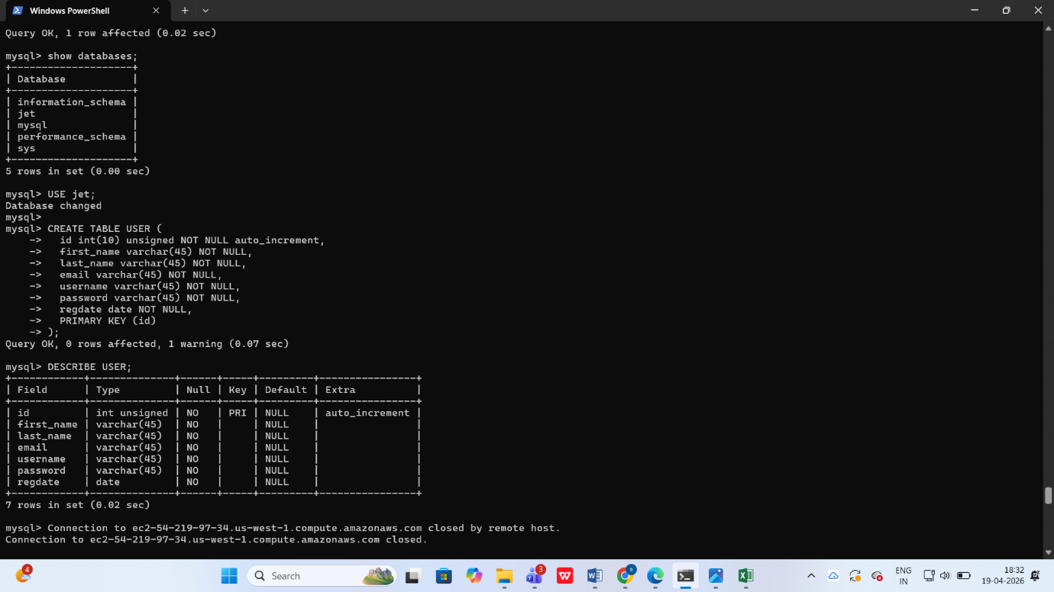

7. Application Configuration Update

🔹 Old Connection (EC2 DB)
jdbc:mysql://<DB-VM-PRIVATE-IP>:3306/jet

🔹 New Connection (RDS)
jdbc:mysql://<RDS-ENDPOINT>:3306/jet
Example:
jdbc:mysql://mydb-instance.abc123xyz.ap-south-1.rds.amazonaws.com:3306/jet

8. Application Testing

🔹 Test Cases

1. User Registration
- Enter user details
- Submit form
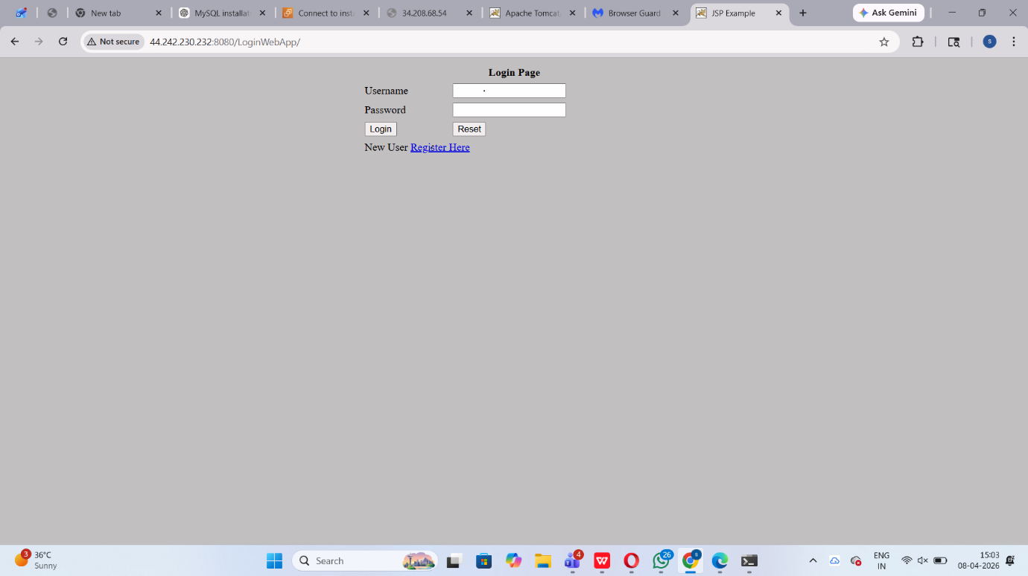

2. User Login
- Login using credentials
- 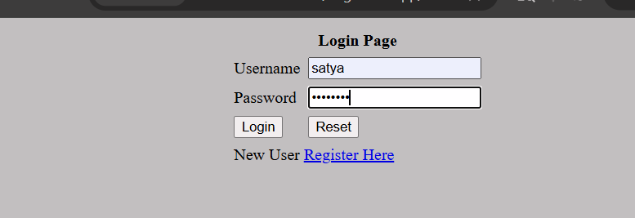

3. Database Verification
Run:
SELECT * FROM USER;
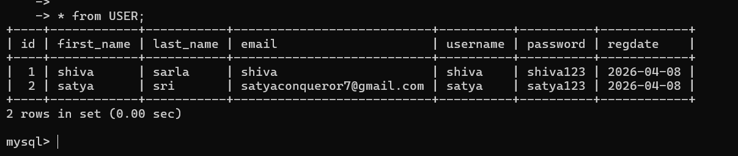

9. Results
- Successfully created RDS MySQL instance
- Connected application to cloud database
- Performed CRUD operations
- Verified data storage and retrieval

10. Challenges Faced
- Connection issues due to:
  - Security group misconfiguration
  - Public access disabled
- Incorrect endpoint usage
- MySQL client not installed

11. Key Learnings
- Difference between IaaS vs PaaS
- AWS RDS simplifies database management
- Importance of:
  - Security groups
  - Endpoint configuration
- Real-world cloud deployment concepts

12. Conclusion
This project demonstrates how to:
- Replace manual DB setup with managed services
- Use AWS RDS for scalable and reliable databases
- Integrate applications with cloud-based databases
👉 Result: Reduced operational overhead + Improved scalability

